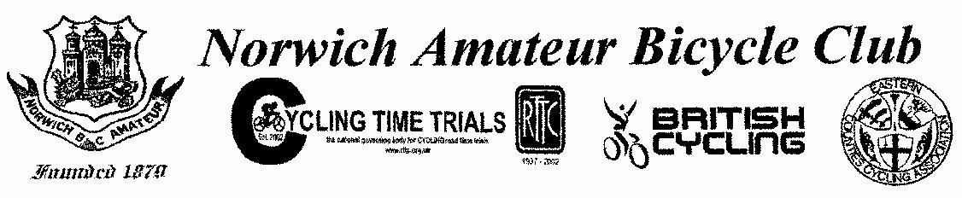

OPEN 25 MILE TIME TRIAL FOR TANDEMS AND SOLOS

Held on **Sunday 6th October 2024** starting at **09.00hrs** on Course B25/50. The event was promoted for and on behalf of Cycling Time Trials under their Rules & Regulations.

**Event Secretary: -** Pete Johnson

6 Vicarage Lane, Mettingham, Nr Bungay, NR351TE.

Tel: - 01986 469359

Mob: - 07708 065338

Email: - jonners43@gmail.com

**Course: - B25/50 (Redenhall – Bungay Bypass Circuit)**

**Awards**

1st male rider on scratch: - Mark Ash (Cake Gang)

1st female rider on scratch: - Julia Freeman (Easterley Road Club)

1st veteran on standard: - Richard Camp (Kings Lynn CC)

Team Award: - Diss and District CC (P. Ellis, L Shipp, K Bell Tye)

**Thanks to…**

Mike Johnson, Larissa Webster and Dick Smith for keeping time.

Ed Dean for pushing off and results board

Martyn Taylor, Geoff Kerss, Jason Turner, Barney Horne and David Howes for marshalling.

Patricia Johnson for refreshments.